ASSIGNMENT 3 - Part 1:

WHAT IS THE RATIONALE FOR INVESTING IN JAEGER PUB?

Minh Doan - Pauline Saintil - Prafull Pande - Xianya Zhong

December 6th, 2021

# Table of Content:

**Abstract**

**3**

**Goals and Objectives**

**3**

**Marketing Management**

**4**

**Financial Management**

**8**

**Appendix**

**11**

# Abstract

The owner of Jaeger Pub has decided to build a new production plant to launch a new Draft Beer brand - Bud Jaeger. Jaeger Pub plans to utilize the available space for the installation of the turn-key system that will ensure production of the draft beer for on premise sales and its wholesale distribution. The implementation plan for the expansion includes hiring and training of additional staff for the production and distribution of the draft beer and includes the investment plan from private institutional financing.

# Goals and Objectives

Jaeger Pub's investment in the draft beer production is based on the growing acceptance of craft-beer in the US and looking at the current scenario especially with the post pandemic relaxation of the COVID norms in most of the states. The major goals and objectives for the new setup are as follows:

1. One of the principal objectives is to initiate new business by adding new space for the production plant of the Draft beer. The new venture can be treated as a separate business venture which involves brewing of draft beer for both on premise consumption and wholesale distribution.
2. The turn-key system to be installed will support simultaneous brewing of up to 8 types of craft beer onsite. The system is capable of brewing at maximum production capacity to meet the market demand.
3. The company has decided to enhance its sales of the Draft Beer for both on-premises consumption and wholesale distribution. This will help maximize the profits and support the new production capacity.
4. The company will be investing into training and development programs for the newly hired employees for maximum efficiency.
5. The company has decided to approach private financial institutions for investment in the new venture. This strategy will help the company get the requisite business and professional expertise required for the success in the venture. This will also derisk the company’s existing business.

# Marketing Management:

The place that would be most beneficial for Bud Jaeger’s product launch would be Cambridge, Massachusetts. The city of Cambridge is home to prestigious universities like Harvard and MIT, which produces graduate students and young professionals who fit our target demographic. The craft beer market is what is known as a “niche market” and caters to a specific target audience. Penetrating this niche market requires adequate research.

**Target Demographic:**

The AHA (American Homebrewers Association), has “membership of approximately 25,000 individuals brewing throughout the United States, this group represents an ideal population from which to gain access to a sample to study craft beer enthusiasm”. (Murray & O'Neill, 2012). The AHA conducted a survey of its members, the demographic for age groups falls on the younger side, with 42% between the ages of 35 - 49. The survey also found that 72% of those surveyed obtain a bachelor's degree or higher, and 63% have an annual income of over $75,000. (Murray & O'Neill, 2012). From this survey insight, it’s probable that this demographic has higher excess income, and higher education, thus allowing them to demand their exact needs. According to the demographic profile of respondents below, about 25% of respondents make over $100,000 a year, and 21.1% have a master's degree. 26.4% fall between the ages 26-34. Overwhelming, 95% of respondents were male (Figure 1).

**Marketing Mix: Place**

According to Cambridge’s 2019 Neighborhood Statistical profile, 29% of the population holds a bachelor’s degree, while an overwhelming 34% majority hold a master’s degree, and 12.9% hold a PhD. Cambridges median household income is $88,976, and median family income is $118,034. The ideal Cambridge neighborhood for the tavern is the East Cambridge area, which has the following demographics: 34% and 14% of the population falling between ages 25-34, and 35-44 respectively. 27.4% hold a bachelor's degree, 34.2% hold a master’s/professional degree, and 14.6% hold a Doctoral degree. The median household income of East Cambridge is $89,818, and the median family household income is $121.056. (Figure 2). This demographic falls directly in line with the AHA research on its members, thus making this the ideal target audience for this product.

**Competitors:**

Cambridge is no stranger to craft beer, thus making an adequate amount of competition available in the area. With the near perfect demographic for craft beer enthusiasts, it’s no surprise there are multiple breweries and craft beer bars located in the city. Competition includes Cambridge Brewing Company, Meadhall, Lord Hobo, and Russell House Tavern.

**Marketing Mix: Product**

The premier product being sold will be Bud Jaeger’s new craft beer. The beer will come in a pint glass, approximately 16 ounces of beer, right from the tap of the tavern's bar. With a target audience that is self-aware and inclined to pay more for what they want; it is imperative that the beer is of excellent quality. Some notable notes of Bud Jaegers craft beer include seasonal changes to the beer, as according to AHA research, “One key result of this study is that while a wide list is desirable it is the frequency of change, comparable to seasonal and frequent food menu changes that are the prime determinant for this market.”. For example, a brew made for fall that has notes of cider or pumpkin, a winter brew that encompasses flavors nostalgic to the holidays, and a summer “ale”, lighter and more relaxed for warmer weather.

**Marketing Mix Promotion:**

Taking into consideration the target demographic age range of 24-44, this is a generation of millennials. Millennials were born in the digital age, making them very well versed in social media. Social networks such as Facebook and Instagram, and Twitter, are most used within the demographic. Running targeted ads on Facebook that show up on their timelines and running those same advertisements on Instagram is sure to attract users to Bud Jaegers social media accounts. Bud Jaeger’s accounts will link to the tavern’s website.

With a demographic that has a high percentage of bachelor's and master’s degrees, this is clearly a case where they welcome learning. Bud Jaeger will offer beer tastings as a promotional event, in which a sample flight of the new brews will be available for tasting. This will be spearheaded by a master Bud Jaeger brew master, who can walk the customers through the beers and educate them further on innovative approaches to creating the beers, and even a tour of where the brewing takes place.

**Price**:

The average price of top craft beers in the United States is calculated as follows: Total Beer Cost = Aggregate Ingredient Costs + Labor Cost + Utilities + Excise Taxes

Total Beer Cost % = Total Beer Cost / Revenue from House Beer Sales.

The ideal price for a pint of Bud Jaegers craft beer is $8.99, which sits above the national average, but is still within reach of the local consumer market. 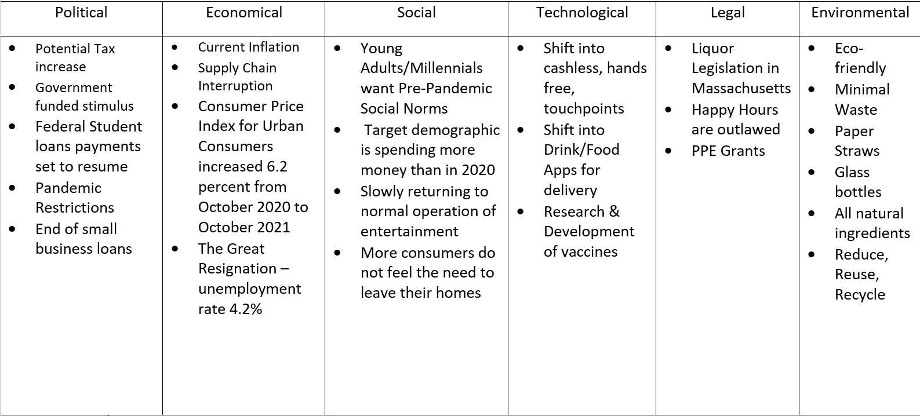

# Innovation Management:

As noted previously, the innovation behind the craft beers comes from the everchanging seasons. Keeping the choices of beer seasonal, enables a freshness that the target demographic will appreciate, as it keeps them interested and always looking forward to the next array of flavors. Introducing new and creative flavor notes to the beers, can also attract unconventional customers. For example, a customer who does not traditionally consider themselves a beer drinker, might enjoy the cider-esque beer we put out in the fall season.

# Financial Management:

Our targeted location is the city Cambridge, Massachusetts. For the business proposal, their minimum requirement is 100 sq ft for production and at least 200 sq ft for wholesale. Their maximum production capacity for monthly is 39,680 pints, which made their annual production to be 476,160 pints. With the assumption that totally 100% of the pints are sold, the current target capital investment is asking for 150,000 USD.

**Capital expenditures:**

From the initial investment, a total of 8 brewing tanks are required. The total cost for the tanks would be 46,400USD, with an average price 5,800 USD (Machine, S.). The location would also include a possible investment into reconstructing a building for the brewery and the wholesale operation. The independent costs of each place vary based on the preexisting conditions, but an average estimation of the construction costs would be 100 USD per square foot. With a minimum of 200 square feet required, average estimation would put the renovation cost at 20,000 USD. Therefore, the total cost for initial set up would be 66,400 USD.

**Operating expenditures:**

However, to operate the place, unless the owner can secure a location to own, the average rental of 200 square feet and utilities would be 1000 - 1600 USD per month, with the current average rental price 50-80 USD per square feet. Working at the place, since the business is new, the owner would be getting involved, and hence have a lower cost for human resources. The median payment for 2 workers would be 50,000 USD for salary (Salary.com, S). However, since these workers would be working full time, the owner would also be paying roughly 50% of the salary for benefits and insurance. That would put the cost at 75,000 USD, or 150,000 USD for both per year. For the first year, no maintenance would be required since the fee is included in the initial investment.

Do note that the first year’s resources for the brewery is also included in the investment. However, from the second year on, the average cost for the resources would be 190,464.00 USD. The current estimated price is 8.99 per pint, so the estimated revenue would be roughly 4,280,678.4 USD. Based on the average Massachusetts beer tax of 0.11 USD per gallon, the total tax for the brewery would be 1,240 USD.

Finally, with utilities used as an add-on from the tavern, the new brewery would not be needing additional utilities setup. However, since the beers must be maintained 24/7, the costs for electricity would be expected to be roughly 1,500 USD per month. That would multiply into 18,000 USD per year.

**Financial analysis tool application:**

*Sales Forecasting:*

The forecasting shows a period of 3 years of simulating demands and how the revenue would reflect the price currently adopted. Based on the marketing planning and initial assumptions, the calculated rate of about monthly 4,500 beer drinkers on premise would be responsible for the crafted consumer. Note that this does not exclude this population from drinking other beverages. Of these 4,500 beer drinkers, since they are also of the age between 24-44, there must be a consideration to their respective income and their willingness to spend on beverages. Considering that not all drinkers are in pursuit of post-secondary education, a respectable amount of almost 3000 are confirmed drinkers, and thus would put the approximate remaining in the working population. These remainders would have a higher tolerance to spending, as they are also earning such money faster than the student population. Should each glass be calculated with the price of 8.99 per pint, and a night out every week, the estimated revenue during the school terms (8 months from September to April) would be at least 323,640 USD - 40,455 USD monthly- assuming the working class to drink two pints, while the students only consume one. This would easily recover the initial cost for the project even in the first year.

*Decision-tree Analysis:*

For the brewery business, the decision factor should be the reception of the crafted beer that would decide the success of it. The amount consumed in the month (due to their longevity in the barrel), should work as an indicator for the business short term future revenue. To consider these percentages of consumption, we must put the success rate at three levels: Optimistic (70-30), Realistic (50-50), and Pessimistic (30-70). The revenue would be calculated as the people who drink at least two pints, and those who only drink one. However, in this scenario, since people are also here to enjoy the meal, they would only consume two pints. Based on the number of patrons calculated in the sales forecast, they consist of 4500 drinkers (Figure 3), and their respective revenue between 12,128 USD and 56,637 USD. After calculating the decision tree (Figure 4), it is recommended that we can proceed with the business with expectation of an optimistic outcome.

# **Appendix**:

Figure 1- AHA Demographic survey results

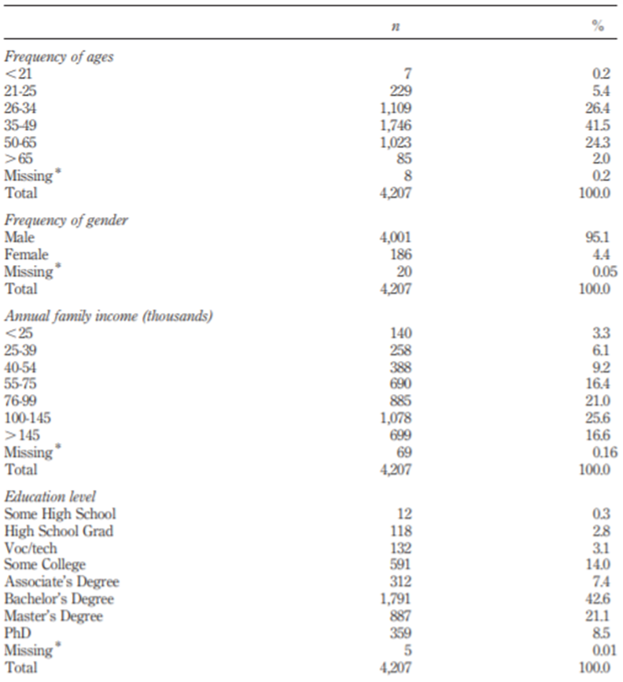

Figure 2- East Cambridge Neighborhood Profile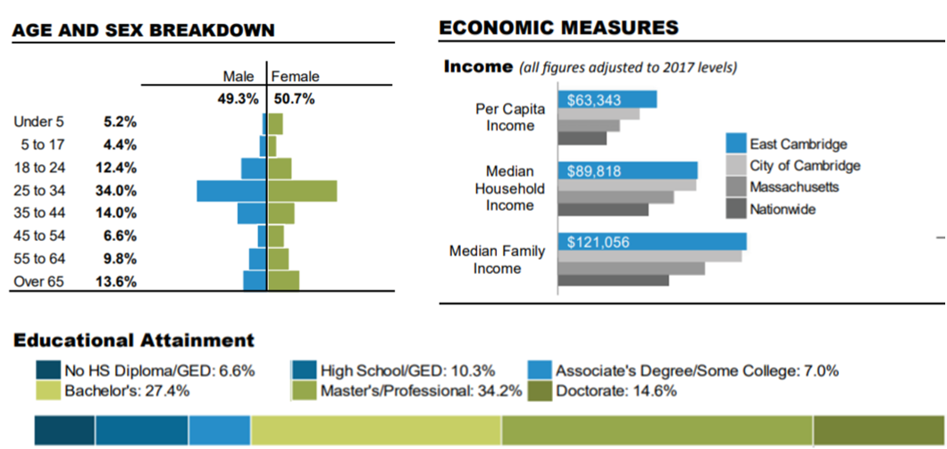

Figure 3: Table of revenue and probability for drinkers at the tavern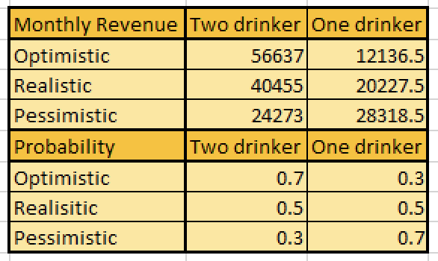

Figure 4: Decision tree that represents the figure 3 table

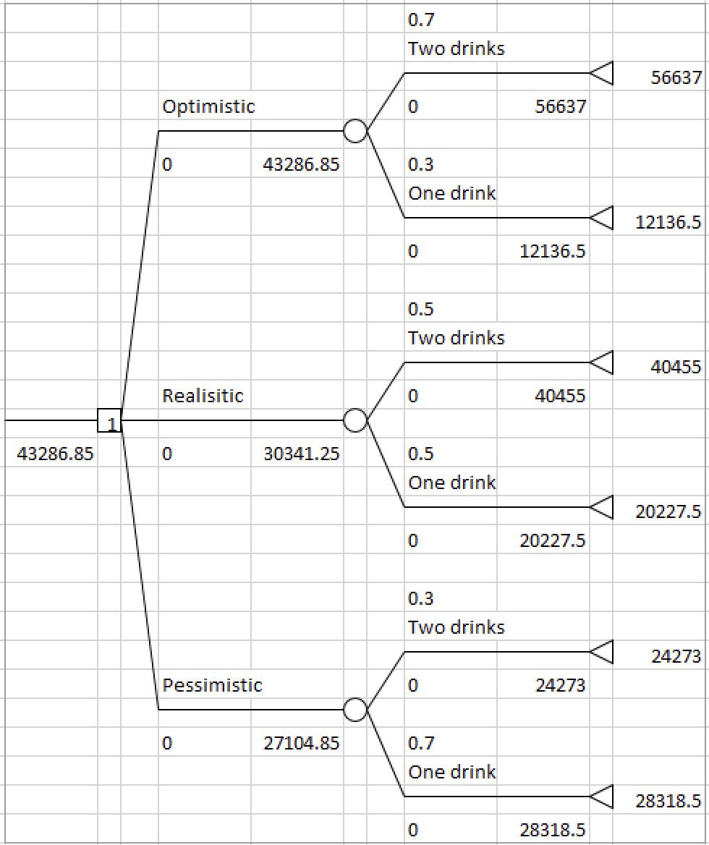

# **Works Cited**

(2019). *Cambridge Neighborhood Statistical Profile.* City of Cambridge, Massachusetts: Community Development.

Machine, S. (2021, February 4). How much does micro-brewery equipment cost?: SMT. Smart Machine | SMT. Retrieved December 6, 2021, from https://www.smartmachine.com/how-much-brewery-equipment-costs-all-sizes/.

Murray, D. W., & O'Neill, M. A. (2012). Craft beer: penetrating a niche market. *British Food Journal*, 899-909.

Salary.com, S. built by: (n.d.). Brewer salary. Salary.com. Retrieved December 6, 2021, from https://www.salary.com/research/salary/posting/brewer-salary.